* Analog to Digital Convertor(ADC) Interfacing
* The data we process in a microcontroller normally deals with digital signals.
* But there may be a situation where we have to deal with external inputs such as analog signals.
* All most all the input signals from physical sensors are of analog signals.
* In such cases, we can interface the microcontroller with an external device such as an ADC 0804, ADC0808 to convert the analog signal to a digital signal.
* Because our microcontrollers can only understand 0 and 1.
* In the present time, there are lots of microcontrollers in the market which has inbuilt ADC with one or more channels, E.g.: PIC18F4550, LPC1768, etc. And by using their ADC registers we can interface.
* If 8051 doesn’t have an internal module, then we will go for an external ADC. Ex. ADC0804, ADC0808.
* ADC (Analog to digital converter) forms a very essential part in many embedded projects
* ADC 0804
* ADC0804 is an 8-bit successive approximation analogue to digital converter from National semiconductors.

The features of ADC0804 are

* differential analogue voltage inputs, 0-5V input voltage range,
* built in clock generator,
* reference voltage can be externally adjusted to convert smaller analogue voltage span to 8-bit resolution etc.

The pin out diagram of ADC0804 is shown in the figure below.

[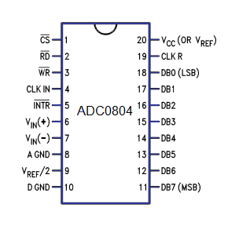](http://www.circuitstoday.com/wp-content/uploads/2012/09/adc0804-pinout.png)

* The voltage at Vref/2  (pin9)  of ADC0804 can be externally adjusted  to convert smaller input voltage spans to full 8 bit resolution.
* Vref/2 (pin9) left open means input voltage span is 0-5V and step size is 5/255=19.6V. Have a look at the table below for different Vref/2 voltages and corresponding analogue input voltage spans.

|  |  |  |
| --- | --- | --- |
| Vref/2 (pin9)  (volts) | Input voltage span (volts) | Step size (mV) |
| Left open | 0 – 5 | 5/255 = 19.6 |
| 2 | 0 – 4 | 4/255 = 15.69 |
| 1.5 | 0 – 3 | 3/255 = 11.76 |
| 1.28 | 0 – 2.56 | 2.56/255 = 10.04 |
| 1.0 | 0 – 2 | 2/255 = 7.84 |
| 0.5 | 0 – 1 | 1/255 = 3.92 |

#### Steps for converting the analogue input and reading the output from ADC0804.

* Make CS=0 and send a low to high pulse to WR pin to start the conversion.
* Now keep checking the INTR pin.  INTR will be 1 if conversion is not finished and INTR will be 0 if conversion is finished.
* If conversion is not finished (INTR=1), poll until it is finished.
* If conversion is finished (INTR=0), go to the next step.
* Make CS=0 and send a high to low pulse to RD pin to read the data from the ADC.

### Circuit diagram.

* [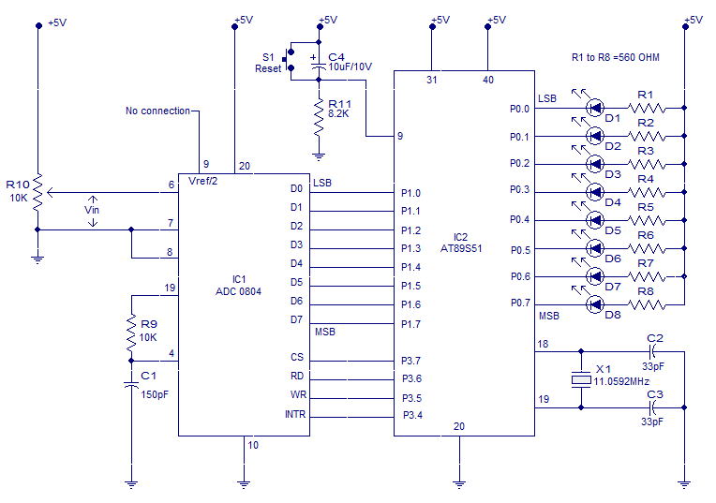](http://www.circuitstoday.com/wp-content/uploads/2012/09/INTERFACING-ADC-TO-8051.png)Interfacing ADC to 8051
* The figure above shows the schematic for interfacing ADC0804 to 8051.
* The circuit initiates the ADC to convert a given analogue input, then accepts the corresponding digital data and displays it on the LED array connected at P0. For example, if the analogue input voltage Vin is 5V then all LEDs will glow indicating 11111111 in binary which is the equivalent of 255 in decimal.
* AT89s51 is the microcontroller used here. Data out pins (D0 to D7) of the ADC0804 are connected to the port pins P1.0 to P1.7 respectively.
* LEDs D1 to D8 are connected to the port pins P0.0 to P0.7 respectively.
* Resistors R1 to R8 are current limiting resistors. In simple words P1 of the microcontroller is the input port and P0 is the output port.
* Control signals for the ADC (INTR, WR, RD and CS) are available at port pins P3.4 to P3.7 respectively.

### Program.

ORG 00H

MOV P1, #11111111B // initiates P1 as the input port

MAIN: CLR P3.7 // makes CS=0

SETB P3.6 // makes RD high

CLR P3.5 // makes WR low

SETB P3.5 // low to high pulse to WR for starting conversion

WAIT: JB P3.4, WAIT // polls until INTR=0

CLR P3.7 // ensures CS=0

CLR P3.6 // high to low pulse to RD for reading the data from ADC

MOV A, P1 // moves the digital data to accumulator

MOV P0, A // outputs the data to P0 for the LEDs

SJMP MAIN // jumps back to the MAIN program

END